Cost benefit analysis procedures to be applied to unwanted organisms or pest responses

Draft discussion paper

Ministry of Agriculture and Forestry
Wellington
New Zealand

Prepared by

Dr John Mumford
TH Huxley School of Environment, Earth Sciences and Engineering
Imperial College of Science, Technology and Medicine
Silwood Park, Ascot, Berkshire SL5 7PY
United Kingdom

May 1999

Contract POH030 Operational Research

- Introduction

The New Zealand Biosecurity Act 1993 establishes the need to conduct analyses of benefits and costs for national and regional pest management strategies conducted by biosecurity ministries, departments and agencies. However, the way in which such analyses are conducted is not specified.

This project describes the process of cost benefit analysis in the context of managing unwanted organisms, discusses issues arising from that and develops some example analyses for a range of organism types and management cases which illustrate some of the approaches and outputs from cost benefit analyses. Excel spreadsheets for case studies on the seaweed Undaria, the southern saltmarsh mosquito and the Asian gypsy moth form part of this report and contain additional text in comment flags.

It should be noted that cost benefit analysis is only one part of the decision making process regarding the management of unwanted organisms. In a major report on harmful non-indigenous species in the United States in 1993 the US Office of Technology Assessment noted that “which species to import and release and which to exclude are ultimately cultural and political choices about the kind of world in which we want to live”. Purely quantifiable economic criteria are not the only considerations, but cost benefit analyses provide an important framework in which technical and economic inputs can be incorporated in these important social and political decisions.

The terms of references as presented in the contract are given below.

2. Terms of Reference

2.1 Objective

The objective of this project is to develop cost benefit analysis procedures that can be applied consistently to decision-making relating to management or eradication programmes of: (i) unwanted organisms under Parts VI or VII of the Biosecurity Act 1993; or (ii) pests under a pest management strategy. Cost benefit analyses resulting from the application of such a procedure will be useful in the preparation of funding proposals for unwanted organism or pest responses; firstly, because in the process of conducting a cost benefit analysis, beneficiaries are identified and, secondly, where benefits can be quantified, some idea of the proportion of costs of a response that should be attributed to the identified beneficiaries is gained.

2.2 Scope

The establishment of Votes Biosecurity has highlighted the need for a consistent approach among departments with operational biosecurity responsibilities to the economic evaluation of proposed management and eradication programmes for pests and unwanted organisms. In the preparation of national and regional pest management strategy proposals, sections 60(1)(l) and 76(1)(l) of the Biosecurity Act 1993, respectively, must be adhered to - that is, an analysis of the benefits and costs of the strategy in relation to each organism to which the strategy would apply is to be included. In addition, in the application of programmes under Parts VI or VII, proposals for additional funding from the Government inevitably require the development of a full business plan, including a cost benefit analysis. Such a requirement can apply during an eradication attempt if further funding requests are lodged.

2.3 Background

Even in undertaking valid economic evaluation of any proposed management or eradication policy, there are problems. For example, each programme is unique and has no history - therefore we do not have and cannot obtain the required information for an accurate evaluation. Even if the evaluator could identify and completely describe all of the consequences of the management or eradication policy, those impacts are more often than not, difficult to compare and weigh.

In addition, a pivotal concept underlying an eradication policy, unlike management (control or containment) strategies, is reducing the target unwanted organism or pest population to zero. Because of the zero population criterion, eradication efforts are subject to the law of diminishing returns. In terms of cost per individual organism, it may be relatively cost-effective to eliminate 90 percent of a population; however that cost usually escalates with the last one percent or so, usually requiring a very costly effort as the eradication effort seeks to achieve 100 percent kill. The same is true of expenditures for detection. Low-level populations can usually be detected and monitored easily, however, detecting these populations with certainty as they diminish becomes increasingly expensive.

It is difficult, if not impossible, to compare the exponentially escalating costs associated with the diminishing returns characteristic of eradication efforts against the ongoing costs of controlling an unwanted organism or pest. However, ideally such comparisons (i.e., no action, management options versus eradication) should be addressed in the cost benefit analysis procedures.

Furthermore, the cost benefit procedures should include approaches to identify the important impacts and specify appropriate evaluative methodologies for measuring and evaluating those impacts, for each management/eradication option (including no action).

2.4 Key Tasks

i There are numerous examples of economic evaluations of eradication programmes. Using New Zealand examples of such programmes (e.g., white-spotted tussock moth, Undaria seaweed, Johnson grass, water hyacinth, salvinia, Cape tulip, hydatids) and overseas examples (e.g., California Department of Food and Agriculture's gypsy moth cost benefit analysis, tsetse fly eradication from Zanzibar), review the approaches and methodologies [including the identification of impacts to human or animal health, food supply, property or any other social concern, the environment; measurement (quantitative and/or qualitative) particularly under uncertainty, and evaluation (including discount rates to be used and dealing with non-market values) of those impacts] used in conducting cost benefit analyses.

ii Through (i) above, identify appropriate, currently-used approaches and methodologies that should be incorporated in the cost benefit analysis procedures. Where necessary, develop/propose approaches and methodologies for aspects of the cost benefit analysis procedures not addressed satisfactorily by current practice.

iii Prepare cost benefit analysis procedures in regard to proposals to pursue management or eradication programmes of unwanted organisms or pests, which assists in the provision of consistent advice to Ministers and other decision-makers (e.g., regional councils). The procedures shall include 3-4 worked examples, covering a range of pest types.

- Review of issues and approaches to cost benefit analysis

Cost-benefit analysis is a descriptive process intended to provide objective information and a transparent framework for the normative decision making process of risk management. The general form of analysis is to present a time series of predicted benefits and associated costs, and to represent these in terms of current year values, often assigning these values to particular geographical areas, agencies or sectors to determine an overall value for a range of potential management options. Cost benefit analysis is not a substitute for decision making itself. Even if a completely standardised cost benefit format were adopted, subjective decisions would still need to be made about that process as well.

There are several major components of cost benefit analysis:

- predicting outcomes, based on a technical assessment of losses if the unwanted organism is not managed, and the management performance of any proposed actions, involving good ecological models
- valuation of inputs and outputs
- distribution of inputs and outputs

The basic principles of cost benefit analysis include:

- determination of selection criteria for management options – based on participation of interested parties
- determination of the baseline scenario against which management will be compared using ecological modelling and risk analysis (assignment of probabilities to ecological events)
- selection of management options for comparison – technical feasibility and efficiency are the primary considerations
- projections of costs and benefits through an agreed sectoral, spatial and time scale
- identification and valuation of benefits – tangible and intangible (where possible)
- determination of the present value of benefit and cost streams over the agreed time scale, discounting for future streams
- selection of the management option based on relevant criteria

The overriding consideration in effective eradication is confidence in the technical effectiveness of the proposed eradication actions. Cost benefit analysis can provide justification for the “expected” outcome (based on probability values), but only if decision-makers really have faith in their ability to achieve eradication. Objective discussion of probabilities in cost benefit analysis should not prevent the enthusiasm and determination that is essential to successful eradication in practice.

The level of detail in analysis must be matched to the level of knowledge and certainty about components of the decision. Therefore, for analyses concerning eradication of unwanted organisms a relatively low level of detail is likely, because of the high degree of uncertainty associated with so many components of the system.

Cost-benefit analysis is important for comparing the economic returns from options with different temporal and spatial dimensions. It is assumed that cost-benefit analysis will be used to identify the option with the greatest overall net benefit. However, cost-benefit analysis does not in itself indicate whether exclusion, detection or control of unwanted organisms should be undertaken, it merely provides information on which decisions can be based.

Probability distribution

While a cost-benefit analysis may normally be expected to indicate the management option with the greatest net benefit, on the basis of the expected value determined by the overall probability weighted outcome, other criteria could be applied depending on the risk distribution (Figure 1). For a case in which there is an unacceptably disastrous tail to a probability distribution of potential losses it may not be appropriate to consider only the median (relatively acceptable) level of risk. For example, even an option with a gross benefit/cost ratio of less than one, where the expected benefit is less than the cost, may be chosen if it reduces an unacceptable risk, even without the expectation of complete success. All insurance is an example of this, the insured expects to pay more on average for insurance than if they accepted the average loss, but they benefit by spreading the cost over many years and many individual cases. This is an aspect that does not appear to have been considered in the Biosecurity Act, since the Act implies that the Minister should be of the opinion that benefits will exceed costs in each particular case. The public may, for example, expect action to be taken to protect a particular species even though the probability of success is low.
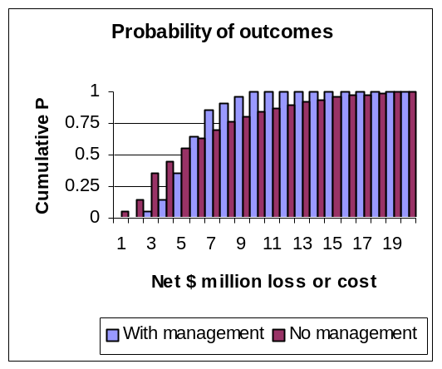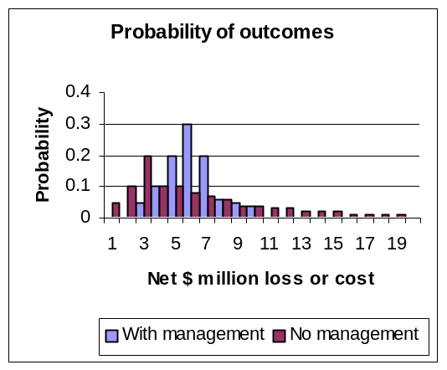

Figure 1a, b. Example probability distributions of outcomes, the full range is important, not just the mean or median value. While “no management” has a higher median outcome (50%), “with management” has a better outcome when 75% of the cumulative outcomes are considered.

The cumulative probabilities from a risk assessment can be included in cost-benefit analysis to give expected costs and benefits based on the median frequency of projected outcomes. Alternatively projections could be based on some other specified proportions of the distribution. For instance the cumulative costs and benefits associated with the 75% point of the probability range could be assessed, rather than taking median probabilities. In Figure 1 a different action would be chosen using the 50% cumulative probability value (“no management”) and the 75% cumulative probability value (“with management”). This may be appropriate if it is important to decision-makers to make a more conservative judgement (incorporating 75% of the probability range). It may be appropriate to apply different objectives in weighting the impact of risks on different sectors facing the risk of introduced pests, for instance natural environments and commercial producers have very different capacities to bear risks.

Apart from the appropriate criteria to use in making a decision and the problems of determining and combining probabilities already discussed with risk assessment, cost benefit analysis has several additional issues in which some compromise may be needed. These involve the choice of duration of the analysis, the discount rate to be applied and the conversion of intangible values to a common monetary value.

Time scale

The duration of cost-benefit analysis is significant when there are high initial costs (for instance in establishing a detection system or undertaking eradication) and protracted or delayed benefits. The longer the duration the greater the opportunity to accrue benefits that recoup the initial costs. However, the longer the duration of the analysis the greater will be the uncertainty associated with the losses or benefits. Some cost benefit studies of introduced pests have used periods of up to 50 years. Such a long period may be appropriate for diseases with very long incubation or latent periods, such as CJD in humans, whereas for eradication of most existing pests which cause immediate and direct loss much shorter periods are more likely to be used. Shorter periods, of 10-15 years, give a much more conservative analysis of the benefits of eradication and acknowledge the relatively high risk of either reintroduction or a new pest invasion. Where there is a history of repeated frequent outbreaks, an even shorter duration should be applied. Economic planning for the eradication of the Mediterranean fruit fly in California and parts of S Africa assumes reintroduction and re-eradication after as little as three years.

Discount rates

The discount rate is used to determine the present value of future costs and benefits so that options with different time frames can be compared. It should reflect the real cost of deferring value over time, often based on the bank interest rate minus inflation rate, which is around 5% per year in developed country economies, but much higher in developing countries due to greater economic and political uncertainty. Thus a benefit or loss of $1 million which comes 10 years in the future has a present value of only $613,913 at 5% annual discount or $385,543 at 10%. The lower the discount rate the greater the present value of a future benefit.

While an individual would normally discount future benefits, some argue that for general public benefits no discount should be applied, since society should place the same value in the future as it does in the present. The discount rate reflects the value society puts on deferring benefits or costs for this particular decision. The willingness to defer the benefit of a decision about health or irreversible environmental damage is likely to be much lower than for a decision about crop losses. Different components of a decision about eradicating an unwanted organism may in fact have different discount rates applicable to them. There is therefore no general discount rate to apply to all unwanted pest species, some are likely to be very commercial in the damage they cause, for example affecting crops or house prices, in which case discount rates should be fairly high to reflect commercial competition for money. Others affect human health and environmental quality and are likely to require much lower, or zero, discount rates.

Intangible values

Intangible benefits include moral, aesthetic, option and bequest values, all of which may apply to aspects of introduced organisms. There is a moral argument against the disruption of nature by allowing harmful new organisms into an environment. The preservation of the natural environment in its original state may have an intrinsic value to many people, even if they can not see any outward difference. Defoliating insects or diseases reduce the aesthetic impact of trees and this can have an important value to homeowners and tourists, beyond the purely economic impact felt by foresters and orchard owners. The presence of a destructive pest not only reduces yields for existing growers of a crop but it also reduces the option of growing that crop for new growers. And finally, people may wish, or even feel it a moral duty, to pass on that natural environment in its original state to future generations.

These values may be significant compared to directly identifiable economic values for many pests, and cost-benefit analyses may need to take them into account. Contingent valuation, in which interested groups are asked to indicate their willingness to pay to prevent the loss of value, is one common method that has been used to determine these values, for example in the case of gypsy moth defoliation. Problems arise over what value to attribute to non-respondents, and whether to use mean or median values. If non-respondents are assumed to be willing to pay at the same value as respondents, then the mean may be overestimated, but if they are assumed not to be willing to pay at all, then the mean will be underestimated. The mean willingness to pay can be used to aggregate values for a large area, while the median willingness to pay is an important political indication of what the typical voter or interested party will accept or demand. A more basic difficulty arises when the environmental asset to be valued is rare or not well known or perceived by many, in which case it is difficult for people to make an informed judgement about their willingness to pay for its preservation. Other methods used to determine such values include calculating the expenditure people make to obtain or avoid similar benefits or losses. Current expenditure to control an existing pest in a crop could be used as an indication of the value the public might put on protecting it from a new pest that might cause similar damage. This depends on how similar the other cases are perceived to be by people, or indeed on the existence of any similar benefits or losses for which people do pay.
The value of human health impacts have been estimated in pest management programmes by relating losses to the cost of treatment (both in and out patient services, including monitoring for illness), lost income from work, or insurance payments for death or illness. In the case of death, mean ages of death and levels of income must be estimated, so that the appropriate years of lost income or insurance payments can be calculated. Similar effects on wildlife and domestic animals have been estimated, assigning token values to individuals of key species. This approach can be criticised for putting arbitrary values on species, and for not including all species which might be affected, particularly poorly known or unseen species, such as soil and marine organisms.

Common criticisms applied to eradication/pest management assessments

Throughout the literature on economic analysis of eradication and management of pests the following critical issues commonly arise:

- The need for an emergency response associated with many eradications results in limited data inputs and meaningless outputs
- Values in decision making often do not reflect stakeholder wishes, there is often political and/or technical dominance in eradication decisions
- Probabilities of spread, impact and control performance remain uncertain despite efforts to get good scientific estimates
- Probabilities (impact, technical performance, reinvasion) are not judged objectively
- Time scales used in analyses are often inappropriate (generally too long on benefits, given the risks of reinvasion and other uncertainties)
- Discount rates are inappropriate (generally too high and too commercial, especially for irreversible invasions of natural environments and for health impacts)
- Spatial resolution is inadequate and does not reflect variability or localisation of impacts
- Distribution issues are not addressed adequately, appropriate equity shares in benefits are not taken into account, nor are moral hazard arguments (are people taking reasonable steps to reduce their own exposure to risk?) represented in recovering costs
- Cost benefit analysis often does not take into account who pays or any novel schemes for funding (which may relate to distribution of benefits, appropriate discount rates, etc)
- The technical plans being compared are not appropriately specified (they may be incomplete or poorly formulated, or may not include the most appropriate option)
- Market and price impacts are not adequately included (price elasticity, market growth, other behavioural responses are not considered)
- Environmental values and other intangibles are inadequately covered (generally ignored)
- Analyses do not adequately include dynamic variables (they often assume all variables remain constant)
- Too often cost benefit analysis is used as a post-event justification rather than as a pre-event decision aid

4. Suggested methods appropriate to cost benefit analyses for management of unwanted organisms in New Zealand

The process for determining the cost benefit for managing or eradicating an unwanted organism generally needs to be done relatively quickly soon after the organism has been detected so that action can be taken before the organism spreads and the costs increase. Non-indigenous organisms are inevitably unique and it is likely that relatively little data on either the impact or success of the management action will be available immediately. It would be unreasonable and unnecessary at this stage to expect a detailed analysis with a definitive prediction of outcome and prescription for action. A more helpful approach would be to provide a general and relatively simple framework for cost benefit analysis that guides the flexible input of scientific and economic information into an agreed format that allows an informed and transparent political decision.

In section 3 a number of criticisms of cost benefit analyses related to pest eradications were noted. Some responses to these specific issues are suggested below.

- Establish standard cost benefit frameworks

The general format of a cost benefit analysis should be accepted prior to conducting one, so that the parties involved understand the general procedure, the data needed and the level of detail available, and the nature of the output. The way that the analysis is conducted can influence its output, for example, through the technical assumptions that are made, and the discount rates, time scales and geographical boundaries that are chosen. A relatively standard format (but bearing in mind that each case is likely to have some unique feature) will ensure consistency and help ensure that data is collected effectively and efficiently.

The output to be specified for a cost benefit analysis should consist of:

- a time series of expected impacts without intervention
- technical management options for proposed actions
- a cost profile of each of the management actions
- a time series of expected impact with intervention
- a time series of benefits resulting from the management action
- a distribution of benefits [geographic, sector, land type]
- economic criteria for selecting options [net present value, benefit cost ratio, payback period, internal rate of return]
- a data table indicating the technical and economic assumptions
- examples of cost and benefit profiles based on sensitivity analysis for key variables [a key variable being one that is likely to change the outcome of the decision over its assumed range]

See Annex 1 for some further general guidelines on a cost benefit procedure.

The output of the cost benefit presentation should be in a relatively simple format that illustrates the flow of benefits in time and space and highlights the general criteria that are likely to be used in making the management decision. Output in the form of a spreadsheet table (with graphs and maps, as appropriate) should provide a direct and simple decision tool.

- Include stakeholders in determining values/establishing methodologies for valuations

Stakeholders should determine appropriate discount rates, time frames, geographical and sectoral boundaries, and the methods for determining the value of losses that might occur and be prevented. Stakeholders should also be willing to back up their values through participation in both the evaluation process and in the subsequent management programme (if one is agreed).

- Relate time scales to uncertainty (more uncertainty, shorter time)

Long time scales are not appropriate to decisions about the eradication of unwanted non-indigenous organisms because there is a relatively high chance of reintroduction, despite efforts to prevent introduction. The payback period for actions should be less than the expected frequency of reintroduction and possible establishment, except in cases where a precautionary approach is agreed (for example, where significant, irrecoverable damage would be done to species or habitats of international importance).

The case studies illustrate how cumulative net present values and benefit costs ratios can be presented for a range of time scales so that decision makers can choose the time frame that is most applicable to their situation. This makes explicit the fact that economic criteria are dependent on the time scale used and may also be highly sensitive to the expenditure or benefits in the final year or years of a time frame. It eliminates the possibility that a benefit cost ratio would be unduly influenced by the choice of time scale.

- Accept social discount rates for non-commercial, irreversible processes

There has been considerable discussion about the choice of discount rates in cost benefit analyses. A reasonable compromise solution would be to use different discount rates for different components of the analysis. For example, social goods such as health values may have a low or zero discount rate, while more commercial values, such as tree defoliation affecting house prices, could be given a purely commercial rate.

In general, given the likelihood of reintroduction of non-indigenous organisms, short to mid-term time scales are most appropriate to cost benefit analyses of their management. In a range of 5-15 years the choice of discount rates is almost certainly going to contribute less variation in the range of outputs than assumptions about the uncertain impact of the organism or the effectiveness of its management.

- Include distribution issues (geographical, sectoral)

Where the impacts of an eradication programme are likely to extend over a large geographical area or several sectors of interest this should be specifically included in the analysis. Examples in the attached case studies include the use of a geographical information system (GIS) to show graphically the spread of infestation and to estimate values of losses from individual kilometre grid cells and a separate sectoral analysis for different groups of fisheries in seaweed management.

- Try to produce a flexible analytical method that allows a range of appropriate management options to be tested

The choice of management action for an unwanted organism should be based on a combination of technical, economic and political criteria that may interact. A cost benefit framework should allow assumptions about the costs and performance of a range of technically appropriate options to be compared. A simple performance model, for example in a spreadsheet, in which management inputs are entered and expected outcomes are presented should be helpful in refining the technical options, and may reveal the most efficient, rather than most effective, technical option.

Including dynamic elements can make analysis very complex, but relatively selective sensitivity analysis can show key variables on which judgements can be made. Examples of sensitivity analysis are illustrated in the case studies.

- Include options for market change (depending on the time frame of the analysis)

In the case of some pests of agricultural commodities that have export markets there may be changes in these markets because of the presence of particular pests in New Zealand. It may be necessary to include within the analysis costs and estimates of the time it would take to prove the absence of the pest species. In some cases it may also be necessary to include alternative markets which tolerate more pest presence as one of the outcomes in the analysis.

- It is important to include impacts on market access or grading in analysis of organisms that affect export standards or tourism potential, where applicable, include price elasticity effects (where the scale of operation is likely to have an effect)

Where pests affect a large proportion of a product there may be significant impacts on price which should be included in an analysis. Studies in the United States have shown considerable impact of pest attack and pest control on market prices for crops ranging from peaches to cotton. In the case of the cotton boll weevil the overall impact on the eradication on prices was estimated by the USDA to result in a negative return due to eradication. An important difficulty in doing this arises because it introduces a further source of uncertainty into the analysis. In addition to variability in the estimates of the impact of the pest and the performance of the pest management options there is added variance due to the prediction of uncertain price impacts.

- Include environmental valuation

Many, if not most, unwanted organisms that enter New Zealand are likely to affect the natural environment, rather than, or in addition to, commercially valued environments. These effects are likely to be very considerable in many cases and should be included in the analysis explicitly. The environment can be valued in various ways, mainly involving contingent valuation to determine a willingness to pay. But it is often difficult to get acceptable valuations, particularly for relatively little known or unseen environments. In many cases it will be either too expensive or unreliable to try to get a valuation. An alternative is to prepare a cost benefit analysis and see what environmental value would need to be added to change the choice of action, and to evaluate the likelihood of that value being a reasonable representation of what society would accept. By this process the decision-maker is, in effect, betting on a particular value being exceeded or not, which should be a much simpler process than trying to assign a specific value. The valuation of the environment is a political expression and the ultimate valuation of the environment is what a Biosecurity minister actually pays, on behalf of the nation, for its protection.

- Conduct cost benefit analyses simultaneously with technical planning so that the two processes inform each other

The largest international organisation involved in pest eradication, the Insect Pest Control Section of the Joint FAO/International Atomic Energy Agency, which is responsible for many major plant and animal pest eradication programmes in Africa, Latin America and Asia has merged the process of technical and economic planning for eradication projects. This has ensured that an economically appropriate range of technical plans can be considered and that economic and technical data related to the cost and performance of eradication plans, which are needed for cost benefit analyses, can be collected at the earliest stage of planning. In some cases this involves field research on technical performance. An important result of this has been to increase the likelihood of cost-efficient technical plans being presented which meet broader political goals.

Establishing the specifications for the inputs into a cost benefit analysis is a first step to integrated economic and technical planning.

- Consider the concept of environmental rent (annual environmental value) rather than environmental asset value

It should be recognised that it may not be possible to keep a natural environment free of unwanted organisms forever. As a result it is more appropriate to use the annual value of the environment, as expressed by access value or some measure of willingness to pay for its presence or maintenance, rather than its full asset value in estimating the benefits of management. While there have been recent efforts to value the environment of New Zealand this value is only maintained while the environment retains its quality and society maintains its appreciation or use of it. The value in relation to invasion by unwanted organisms is, therefore, only the value over the years between now and the next occasion on which that or another unwanted organism changes the value again.

- Case study examples

Four case studies of cost benefit analyses were selected in discussion with the biosecurity ministries. While there are common elements to these analyses they also illustrate unique properties. The presentation of these case studies focuses on the cost benefit analysis itself without going into great detail on the technical background of the examples, which have been examined in detail by the ministries concerned.

The first case is Undaria, a seaweed affecting the east coasts of North and South Islands and Stewart Island. The technical issue concerns the removal of seaweed from an inlet in Stewart Island and the analysis highlights the issue of the frequency and rate of reinvasion. The seaweed clearance has been proposed by the Department of Conservation and involves ongoing management rather than permanent eradication.

The second case is the Southern saltmarsh mosquito, a potential vector of Ross River virus, which was discovered at Napier in December 1998 and has been the subject of an eradication/containment programme subsequently, organised by the Ministry of Health. Important issues raised in this example are the estimation of epidemic infection rates in a human population that has no history of the disease, the valuation of illness and of nuisance, and the timing of possible mosquito outbreaks in other major urban areas.

The third case is the Asian gypsy moth, a defoliator of deciduous trees, which has been detected by the Ministry of Agriculture and Forestry in New Zealand on ships and used cars coming from NE Asia. Much of the damage caused by gypsy moth is aesthetic and affects urban householders. An approach using a geographical information system to predict the spread and to assign values for potential benefits for each square kilometre is illustrated.

The fourth case is Newcastle disease, which affects poultry in Australia and several other countries in the region. It can also affect ostriches and potentially kiwis. The response to Newcastle disease in other countries is to destroy all affected flocks immediately on detection of virulent infection. Because of effective destruction there is little data on rates of spread. Newcastle disease is an example in which the precautionary principle should be applied, immediate but limited action can be taken on poultry farms where there is a strong interest in preserving a disease free environment.

  - Undaria seaweed

Undaria pinnatifida is a brown seaweed, which was first discovered in New Zealand waters in 1987. It has spread along most of the east coast of North and South Islands and Stewart Island. Undaria disrupts the environment for native seaweeds and shellfish and reduces the return on commercial fisheries.

A Department of Conservation review made in January 1999 indicated that it is technically feasible to remove Undaria by scouring the seabed along the shoreline and keeping the area free of Undaria by continual mechanical defouling of any ships and equipment entering the cleared area.

A spreadsheet (undaria.xls) is attached showing the projected cost benefit analysis for Undaria clearance. The analysis uses a relatively long time scale of 24 years. The reason for this is that it is expected that there will be a reinvasion of Undaria in the proposed clearance in Paterson Inlet in Stewart Island at some time in the future. When there is a reinvasion it will be necessary to reclear the area, and the benefit cost ratio will be affected at that time. The reinvasion rate and the clearance threshold are two variables included in the analysis.

This example uses two discount rates, one is the commercial rate which is applied to benefits to commercial fisheries and the other is an environmental discount rate which is applied to noncommercial benefits, for example preservation of the environment for native seaweeds and shellfish.

The environmental value of clearing Undaria can be entered as a variable in the model. It would be difficult to establish a value by contingent valuation methods because of the relatively few people familiar enough with the potential impact Undaria in Stewart Island to give an informed opinion. Therefore, the model is designed to test the level of environmental value needed to affect the overall decision. A subjective evaluation could then be made on whether that level of “value” was reasonable.

The impact on commercial fisheries, mussel and salmon farms has been estimated for three cases (low, medium and high impact) by the Department of Conservation and each cases can be included in the model. The full impact on fisheries and the natural environment takes 20 years to occur, up to 10 years for mussel farms, and three years for salmon farms.

The economic criteria presented are the expected net present value, which is shown as a cumulative sum up to each year, and the cumulative gross benefit/cost (B/C) ratio. The gross benefit cost ratio should be greater than one to make eradication the appropriate choice.

An analysis using a medium impact case, with a reinvasion rate of 5% (the model is deterministic, the expected benefits are reduced by 5% per year to account for this), and a reclear threshold set at a cumulative reinvasion level of 50% and an environmental value rising linearly to $100,000 per year at year 20 would begin to have a positive net present value from year 19. For most technical assumptions it would take a substantial environmental value, in addition to the commercial benefits, to achieve positive net present values within a 10 year period.

For the assumptions listed above, the environmental value would need to rise to $600,000/year to achieve a positive net present value by year 10. In this case study, the environmental value has not been quantified. However, the clearance of Undaria can be subjectively compared with other potential management activities that the Department of Conservation could undertake over that time period to decide which has the best likelihood of achieving good environmental returns.

The shaded cells in the spreadsheet contain the variables that can be changed. Comments on the values chosen, and other explanations, are indicated by red flags in some cells.

5.2 Southern saltmarsh mosquito

The southern saltmarsh mosquito (Aedes camptorynchus) was found at Napier just before Christmas, 1998. This mosquito is a vector of Ross River virus, an endemic disease in Australia, which causes an inflammation of the joints in humans. Over 6000 cases of Ross River virus were reported in Australia in 1997. The disease is also known in Papua New Guinea, the Solomon Islands, Fiji and parts of Malaysia. The reaction to the disease is different in different individuals but many people require treatment by a physician and must take time off work. In addition, there is potential nuisance value to the biting of the insect, even when it is not acting as a vector. There is no indication of the presence of Ross River virus in New Zealand yet.

When the mosquito was identified in Napier a containment operation was started by the Ministry of Health and has continued during the first four months of 1999. An eradication program was proposed and a cost-benefit case study was undertaken as part of that exercise.

A spreadsheet (mosquito.xls) is attached which shows the output of that cost benefit study.

The economic analysis was developed in parallel with a meeting of the technical advisory group assessing Ross River virus impact and its control initiated by the Ministry of Health in March 1999. The technical advisory group provided values for the model, and responded to observations on the sensitivity of the economic outputs to some technical estimates.

A critical variable applied to sensitivity analysis for this case is the rate of infection in the event of a Ross River virus epidemic and the proportion of infected people who would be affected seriously enough to report the illness to a doctor and to take time off work. There is great uncertainty about the potential impact of the disease in New Zealand because the experiences of epidemics in Australia and in Fiji are very different. Other variables that are particularly important in this analysis are the years when the mosquito, and the virus, are expected to spread to Auckland. In the most severe scenario considered the value of losses in Auckland in the initial outbreak year would be over $45 million, whereas in the least severe scenario the value in Auckland in the initial year of infection would be around $2 million. This range of uncertainty in the likely severity of an epidemic is far more significant than the variability in the estimates of the value of time off work or other economic variables.

The analysis presents three scenarios with different severities of Ross River virus infection. Net present values are shown for each year to 2014 and the net benefit/cost ratio [(B-C)/C] is shown for three example years. The middle case represents a median probability of impact from the disease.

The high impact scenario indicates very serious losses to human health and a moderately risk averse response to such a problem would be to undertake eradication. However, the median assumptions in the cost benefit model, as discussed with the technical advisory group assembled by the Ministry of Health, would be considered for a long-term risk neutral response. In this case there would be only marginal returns from eradication, although there are positive net benefits in many years.

This example demonstrates the role of cost benefit analysis in highlighting critical technical assumptions that affect decisions. It also demonstrates that, given this uncertainty, the decision on eradication is still largely determined by risk attitude, although the basis for this is given added weight by the economic quantification of the range of possible epidemiological scenarios.

The shaded cells in the spreadsheet contain the variables that can be changed. One sheet of the spreadsheet is used to summarise the variables that make up the impact and cost models. Comments on the values chosen, and other explanations, are indicated by red flags in many of the cells.

  - Asian gypsy moth

This case study uses the example of the Asian gypsy moth to illustrate how geographical information systems could be used in conjunction with economic survey data to calculate the potential costs of its introduction into New Zealand and then to specify control levels appropriate to the value of potential losses.

Vegetation data from satellite images were used to generate a prediction for the spread of gypsy moth across North and South Islands. The rate of movement was based on a function of vegetation type that results in maps and tables showing a time series of infestations by location and vegetation type. A value function can then be applied to give an estimate of loss over time per unit of area.

Data regarding vegetation and land cover type were downloaded from the US Geological Survey (USGS) website. Data for New Zealand were extracted from the USGS Land Use\Land Cover Characteristics files for Australasia and the Pacific. This data set uses a resolution of one pixel per km². Documentation files were created and the vegetation type image file was viewed for the Pacific and Australasian area using the Idrisi GIS software package. This software was used to conduct most image editing and processing.

The New Zealand images were extracted from the larger continental image. Seven types of land cover were shown in the image using the USGS data set. A new palette was assigned to the image to make the colours of vegetation types more identifiable (Figure 2).

It is anticipated that the spread of the moth through new areas will be a function of the suitability of the vegetation type and the density of potential hosts. Idrisi allows the user to define the “friction” of isotropic movement (equal in all directions) through different substrates radiating from a point source. The relative frictions to movement through the different vegetation types were estimated. These were based on the premise that spread through urban areas would be most rapid and were classed as having the lowest friction. These values were then assigned to the vegetation map for the whole of New Zealand producing a “friction surface”. These values are used to illustrate the process and are not definitive.

Two points of potential infestation were selected, one on North Island and one on South Island, Auckland and Dunedin, respectively. Each island was extracted as a separate image and the vector files of the point sources of infestation were allocated to each map. Once the vector files for the ports in each island were applied, they were converted into a boolean raster image file.

A boolean raster image file was specified indicating Auckland as the point source of the introduction together with the New Zealand friction surface file. The accrued “cost” of movement away from Auckland was calculated where a lower accrued cost represented a point where infestation would be reached more rapidly than a point holding a higher value. This gave 256 isoclinal contours for the spread of infestation from the source point of Auckland. The model calculated the potential spread of the gypsy moth across each vegetation surface so that the potential spread of the pest by year could be assessed. The reclassification was based on the potential of the adult moth to spread through a homogeneous urban area (which gives the fastest spread) which was estimated at about 300 km per year. At face value this appears to be a very high figure but it is important to note that the assumption is based on ideal conditions for gypsy moth spread. The environment of South Island (Figure 4) is, however, highly heterogeneous and results in the predicted average spread of circa 60 km of linear spread per year (Figure 6). In Figures 5 and 6 the results are expressed graphically as the yearly spread of gypsy moth. This model predicts that it would take approximately 10 years for the Asian gypsy moth to cover South Island (although it would, clearly, only persist in any numbers in broadleaf deciduous areas).

Each vegetation type for both North and South Islands was then reclassified as a boolean file so that pixels holding a value for a particular vegetation type were reclassed as having a value of one while all other pixels were reclassified as zeros. Then an overlay function was used which allowed the user to specify the mathematical combination of two files to create a third. Thus by multiplying the vegetation type files with the yearly spread files it was possible to view the area of each vegetation type in each years spread. The area module was then run on the product file to quantify the exact area resulting from the overlay operation. These outputs were then compiled on a spreadsheet for each vegetation class in each year of spread. This allowed the user to assess the potential value of loss through time.

Tabular summaries of the increase in infested areas and their vegetation classes are contained in Table 1 for North Island and Table 2 for South Island. Figures 2, 3 and 4 show the vegetation types for New Zealand and for North and South Island respectively. Figures 5 and 6 display the model prediction of spread from the infestation sources of Auckland and Dunedin. Figures 7 and 8 graph the accumulated areas for each vegetation type within the infested areas over time for North and South Islands.

The CLIMEX climatic matching program was used to check climatic suitability for gypsy moth in New Zealand (Figure 9). The output shows a close match for the climate in New York in the central part of the North American range of European gypsy moth.

A spreadsheet (gypsy.xls) is also included in which a cost benefit analysis is presented for the eradication of an established gypsy moth outbreak in Auckland (costs based on the 1996 tussock moth eradication). The potential losses for the North Island are based on the spread estimated by the GIS method described above and example values of trees are drawn from American and New Zealand studies.

A 12-year time frame is used, which extends beyond the estimated time for the insect to spread throughout the North Island. Because gypsy moth has been found on several occasions on shipments from Asia in recent years the likelihood of reinvasion is fairly high and it would not be reasonable to extend the analysis to a longer time frame.

Losses are estimated within five broad vegetation types and losses associated with defoliation are separated from losses of value due to tree death. With the GIS based estimate of spread the losses could also be presented by vegetation type within regional boundaries for regional planning.

Because most of the loss is in commercial value a relatively high commercial discount rate is illustrated in the spreadsheet.

Comment flags in the Excel spreadsheet provide further explanation of the values used in the illustration.

As in the cost benefit analysis of the tussock moth in New Zealand (Clough, 1997) the key impact is the value of losses due to the death and defoliation of urban trees, particularly in Auckland. This is very sensitive to the estimation of mortality rates for trees due to infestation, which would be a high priority for investigation in areas where the gypsy moth is already endemic. The value of tree mortality used in the analysis is very low, at 0.5% per year. The value of susceptible trees per ha in urban areas is very low compared to US studies because of the much lower proportion of trees that would be susceptible to attack by gypsy moth in New Zealand urban areas (exotic deciduous broadleaf trees would be most at risk).

No fixed time scale is used in the analysis. Cumulative net present values for up to 12 years are shown, along with cumulative net benefit cost ratios for the same period. Both net present value and net benefit cost ratios [(B-C)/C] are positive after 3 years, and continue to rise. The choice of time scale depends on the risk attitude and perception of the decision-maker, and should not be built into the analysis other than as a variable.

An important consideration in this case is the frequency of introduction and establishment of Asian gypsy moth. While the mid to long term benefits of eradicating an established infestation are high, there is at least a three year pay-back period to break even on eradication, given the assumptions in the spreadsheet prediction. Unless reintroduction could be prevented for 4-5 years with some certainty the eradication would not give a very good return. The success of the tussock moth eradication indicates that gypsy moth eradication would be very likely.

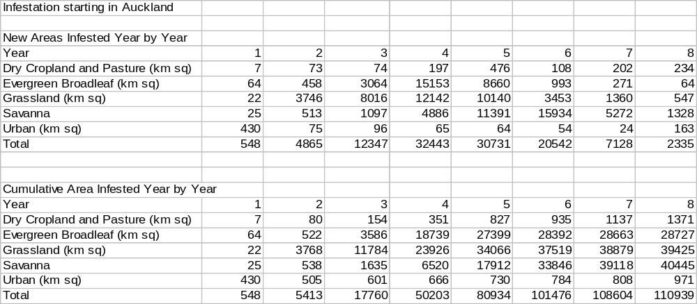
Table 1. Potential spread of gypsy moth by year in North Island introduced through Auckland (km²).
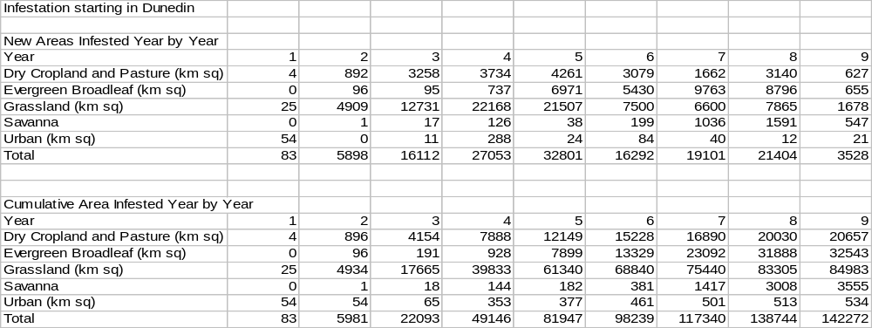

Table 2. Potential spread of gypsy moth by year in South Island introduced through Dunedin (km²).

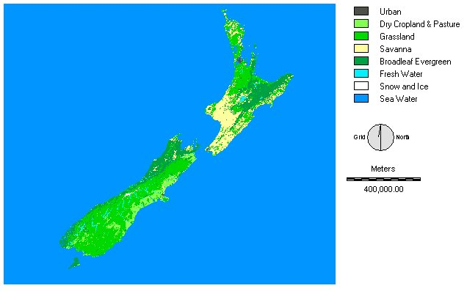
Figure 2. The vegetation map of New Zealand

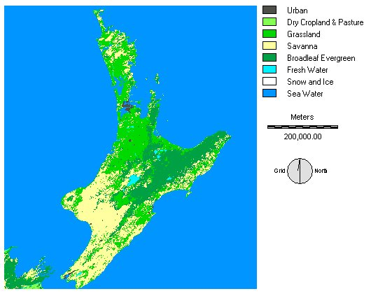
Figure 3. Vegetation map of North Island.

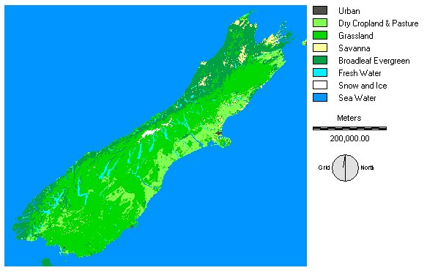
Figure 4. Vegetation map of South Island.

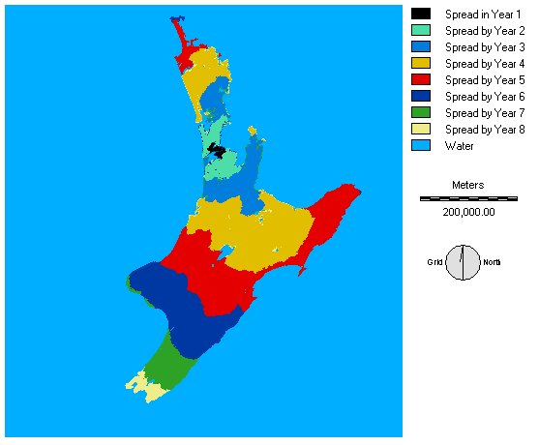
Figure 5. Modeled prediction of spread of the Asian gypsy moth through North Island (with initial infestation starting in Auckland).
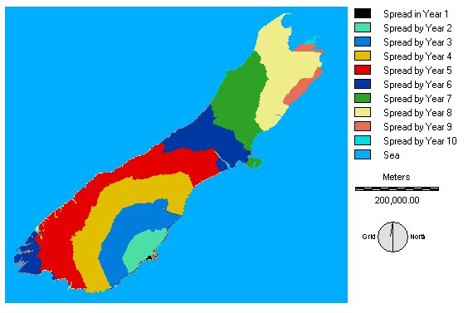
Figure 6. Modeled prediction of spread of the Asian gypsy moth through South Island (with initial infestation starting in Dunedin).
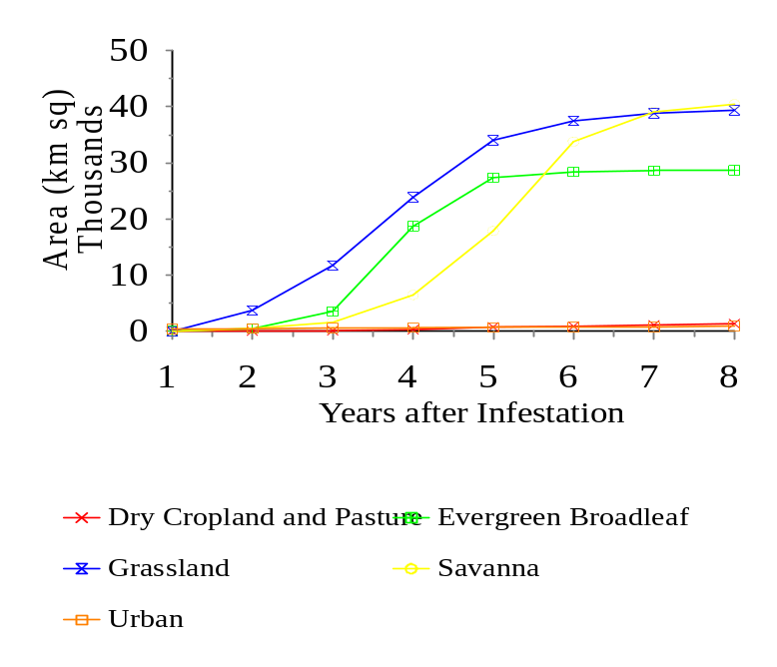Figure 7. Yearly accumulated infested area for North Island (with initial infestation starting in Auckland).

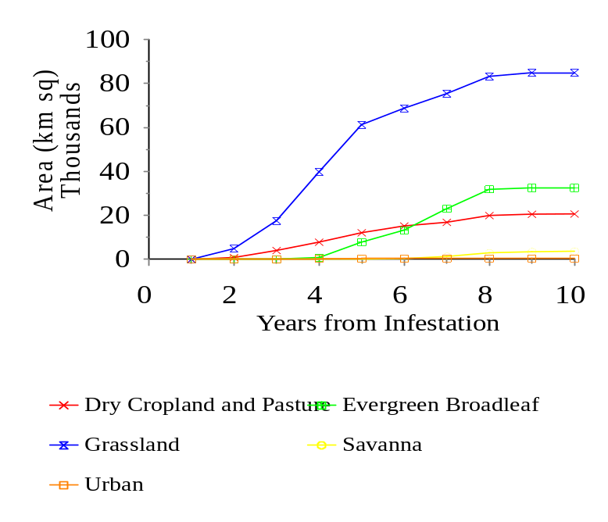
Figure 8. Yearly accumulated infested area for South Island (with initial infestation starting in Dunedin).
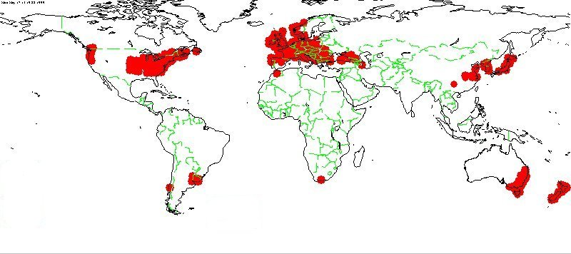

Figure 9. CLIMEX map showing climate matching for New York indicating suitability for gypsy moth in New Zealand. CLIMEX is a climatic matching program from CSIRO, Australia.

  - Newcastle disease

Newcastle disease is a highly contagious, generalised virus disease of domestic poultry, cage, aviary and wild birds which is capable of causing catastrophic losses. The disease has never established in New Zealand although the Biosecurity Risk Assessment exercise rated the risk of introduction as moderately likely and the consequence of entry as severe. Several species of birds that migrate to New Zealand have been shown to carry the disease although imports of smuggled live birds and legitimate imports of poultry and poultry products are a more likely source of outbreak. There are two aspects to losses associated with Newcastle disease. The first, losses to poultry and avian livestock farmers, would, given the appropriate information, be relatively easy to assess. However, the second is more subjective in that it involves the assessment of the risk of spread through the wild bird population and the value of wild birds.

There are three different levels of incidence and management of Newcastle disease, where:

- it is endemic, necessitating wide scale immunisation to avoid losses, such as in Papua New Guinea
- it is regularly brought in by wild birds/poultry imports where combinations of vaccination strategies and culls of infected premises are used to manage outbreaks, such as in the United Kingdom
- outbreaks are rare because of geographic isolation/tight quarantine/hygiene policy where a destruction/elimination policy can maintain disease free status, such as Australia and New Zealand

The Ausvetplan for Newcastle disease (1996) is the most appropriate to New Zealand where rapid elimination of the disease in commercial poultry would minimise the risk of the virus spreading to wild bird populations. The flock destruction policy is not compatible with widespread use of vaccination where outbreaks may be masked by contagious birds appearing to be unaffected thereby making rapid response to an outbreak of the disease slower and thereby more difficult to isolate.

There are two aspects to consider in an outbreak in New Zealand:
- the cost and resultant benefit of controlling or eradicating a Newcastle disease outbreak in poultry
- the more subjective problems of potential losses of important wild bird species such as the four kiwi species of New Zealand.

For New Zealand the costs of implementing a flock destruction policy for an outbreak of Newcastle disease in commercial farms and domestic pets would include periodic media campaigns prior to any sign of infection and reporting, testing and destruction costs on affected properties, and testing of wild birds, once an infection was reported.

Costs will be associated with the implementation of Restricted and Control Areas. In Restricted Areas (RAs) sampling and testing of birds and trace back procedures would be used to classify properties into Infected Premises (IPs), Dangerous Contact Premises (DCPs), and Suspect Premises (SPs) and also the extent of the RA and CA area. All movement of goods, vehicles, persons and livestock between farms would be restricted subject to permission (licensing) which will affect local trade and thus have indirect costs associated with declaration of RAs and CAs. Culling of all birds on infected and dangerous contact premises will be a considerable direct cost of a flock destruction policy. Uninfected flocks (where no sign of infection has developed during the declared incubation period) in SPs would be recommended for immediate slaughter and then sale for human consumption.
The costs of monitoring an outbreak by sampling and serological testing in RAs, CAs and in wider geographical surveys would be directly associated with the sampling system that satisfies prescribed criteria. The Ausvetplan states that wide geographical surveys should aim at 95% confidence of detecting a 5% infection rate in 1% of commercial flocks.

Once an outbreak is identified trade sanctions may be implemented on poultry products from New Zealand by disease free countries. For a previously disease free country that operates a flock destruction policy, such as New Zealand, this would last for six months after the last case is identified, or for three years for other countries. This would have greater importance in countries where the majority of poultry products are exported rather than being consumed domestically, as in New Zealand.
Vaccinations are principally prescribed in the Ausvetplan for protecting valuable genetic breeding stock. Vaccinations would also be appropriate for an epidemic where rapid spread has already occurred in which case a “ring” of immunised uninfected birds would encircle the epicentre of infection and immunisation would proceed from the perimeter of the ring into the middle. Immunising from the perimeter in rather than centre out would prevent accidental spreading of the disease from infected premises to uninfected ones.

The threat of Newcastle disease to wild birds and in particular the four kiwi species will be a product of the proximity of kiwi population to points of outbreak and the susceptibility of the birds to the disease. It is known that other ratites such as ostriches are susceptible to the disease but there are no data to indicate whether kiwis are more or less susceptible than ostriches nor that the current types of vaccine will confer immunity. As the loss of kiwis from New Zealand would be irreversible a precautionary approach is required as opposed to the pragmatic approach that can be applied to outbreaks in poultry farms.

With the appropriate data it would be possible to assess, or at least estimate, the potential spread of the disease through wild birds if some data could be gathered on susceptible species and their distribution. Through a combination of simple epidemiological and GIS modelling a risk profile of the spread of the disease under a variety of conditions could be provided. Figures 10 and 11 show the distribution of kiwis in North and South Islands. It would be possible to overlay the locations of poultry producers and/or potential entry points for the disease and interpolate probabilities of disease transference through fomites and natural vectors. The costs of a variety of strategies could then be estimated although any strategy for the control of the disease in most wild birds species are likely to be very expensive.

Cost benefit approach to Newcastle disease

Newcastle disease is a classic case for application of the precautionary principle in pest management. It would be difficult to conduct a traditional cost benefit analysis on a disease like Newcastle disease because of the lack of probability data on which to base expected returns. In part, this results from the strict flock destruction programs in other countries such as Australia and the United Kingdom. Because of flock destruction there is little data available on the rate of spread of the disease. In cases where data is unreliable or unavailable a cost benefit analysis would need to rely on a very wide range of sensitivity analyses, using a range of probabilities of invasion and spread. Evidence from these campaigns in other countries indicates that the cost and frequency of flock destruction is very low and it is very effective.

The precautionary principle is sometimes criticised because in some cases it can give rise to high preventative costs where there is little return. In the case of Newcastle disease the routine costs are known to be relatively low, including only publicity and monitoring. Immediate control costs are also relatively low if infected flocks are discovered early. There is, therefore, little reason to question with a detailed analysis a satisfactory preventative management policy that does not have potentially high or open-ended costs.
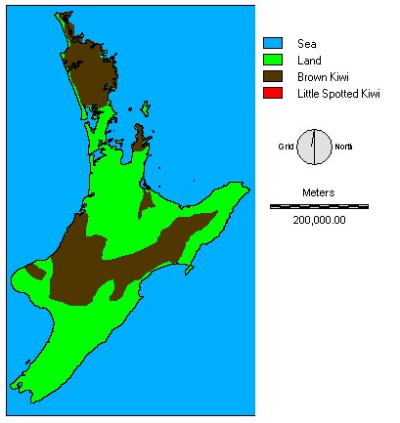
Figure 10. Distribution of kiwis in North Island. The position of poultry farms could be overlaid to give an indication of risk potential.

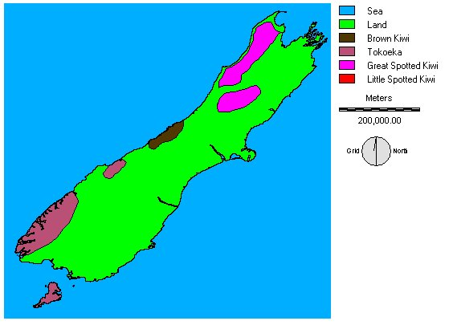
Figure 11. Distribution of kiwis in South Island.
Acknowledgements

My thanks to Dr Ruth Frampton (MAF), Andrew Forsyth (MoH), Sean Goddard (DoC), and Camilla Cox (Fisheries) who were the principal contacts in the Biosecurity Ministries, and Peter Clough (NZ Institute of Economic Research), along with many other colleagues in the various ministries who provided helpful information and discussions during this project.

Dr Adrian Leach, Sheena Sloan and Valerie Walters helped with information and case studies at Silwood Park.

References

Bartlett, P.W. 1996. Tephritid fruit flies - A quandary for international plant quarantine. BCPC Brighton Crop Protection Conference - Pests and Diseases - 1996, pp1153-1160.

Biodiversity, Our Living Treasure. 1998. Our chance to turn the tide. Department of Conservation and Ministry of Environment, Wellington, NZ.

Brett, T. & Stuart, M. Potential impacts of Undaria pinnatifida on aquaculture and fisheries. Ministry of Fisheries & Department of Conservation, Wellington, NZ.

Bright, C. 1998. Life out of bounds. W.W. Norton & Co, New York, USA. 287pp. ISBN 0-393-31814-1

Carey, J.R. 1992. The Mediterranean fruit fly in California: taking stock. California Agriculture, 46:13-17.

Carter, P.C.S. 1989. Risk assessment and pest detection surveys for exotic pests and diseases which threaten commercial forestry in New Zealand. NZ Journal of Forestry Science, 19:353-374.

Clark, C.W. 1990. Mathematical bioeconomics: the optimal management of renewable resources. John Wiley and Sons, New York. 386pp.

Clough, P. 1997. White spotted tussock moth eradication cost benefit analysis. NZ Institute of Economic Research, Wellington, NZ.

Clough, P. 1998. The marginal value of conservation. NZ Institute of Economic Research, Wellington, NZ.

Dahlstein, D.L., Garcia, R., Lorraine, H. (eds). 1989. Eradication of Exotic Pests: Analysis with Case Histories. Yale University Press, New Haven, USA. 296pp.

Eden, W.G. 1978. Eradication of plant pests - Pro. Entomological Society of America Bulletin, 24: 52-54.

Enkerlin, W. & Mumford, J.D. 1997. Economic evaluation of three alternative control methods of the Mediterranean fruit fly (Diptera: Tephritidae) in Israel, Palestine and Jordan. Journal of Economic Entomology, 90:1066-1072.

Fielding, N.J., Evans, H.F., Williams, J.M. & Evans, B. 1991. Distribution and spread of the great European spruce bark beetle, Dendroctonus micans, in Britain – 1982 to 1989. Forestry 64: 345-358

Griffin, R.L. 1997. An example of a cooperative risk assessment: Scenario analysis for the risk of pine shoot beetle outbreaks resulting from the movement of pine logs from regulated areas. pp87-102. In: Kamrin, M.A. (ed), Environmental Risk Harmonization, John Wiley & Sons, Chichester, United Kingdom. ISBN 0-471-972-657

Hawkes, R.A., Boughton, C.R., Maim, H.A. & Stallman, N.D. 1985. A major outbreak of epidemic polyarthritis in New South Wales during the summer of 1983/1984. The Medical Journal of Australia, 143: 330-333.

Jakus, P. & Smith, V.K. 1991. Measuring use and nonuse values for landscape amenities: a contingent behavior analysis of gypsy moth control. Discussion paper QE92-07. Washington, DC: Resources for the Future. 48 pp.

Kay, B.H. 1997. Review of New Zealand programme for exclusion and surveillance of exotic mosquitoes of public health significance. Ministry of Health, Wellington, NZ.

Kazmierczak, R.F. 1996. Differences between landowner and producer support for the Louisiana boll weevil eradication program. J. Agric. Entomol. 13: 375-391.

Kehlenbeck, H. 1996. Model cases for evaluating the impact of pest introduction and phytosanitary measures. European Plant Protection Organisation Bulletin, 26: 537-543.

Klassen, W. 1998. Area-wide approaches to insect pest interventions: History and lessons. Abstracts of FAO/IAEA International Conference on Area-wide Control of Insect Pests. IAEA-CN-71, IAEA, Vienna, Austria.

Klassen, W. 1989. Eradication of introduced arthropod pests: Theory and historical practice. Miscellaneous Publications of the Entomological Society of America. 73: 1-29.

Knipling, E.F. 1978. Eradication of plant pests - Pro. Entomological Society of America Bulletin, 24: 44-52.

Knipling, E.F. & Stadelbacher, E.A. 1983. The rationale for area wide management of Heliothis (Lepidoptera: Noctuidae) populations. Bull. Ent. Soc. America. 29: 29-37.

Le Veen, E.P. Economic evaluation of eradication programs. 1989. pp41-56. In: Eradication of Exotic Pests: Analysis with Case Histories. Dahlstein, D.L; Garcia, R. & Lorraine, H. (eds). Yale University Press, New Haven, USA. 296pp.

Levin, S.A. 1989. Analysis of risk for invasions and control programs. In: Biological Invasions: a Global Perspective (Drake, J.A. et al. (eds)) 1989 SCOPE, John Wiley & Sons Ltd. pp425-435

Lewis, V.R., Merrill, L.D., Atkinson, T.H., Wasbauer, J.S. 1992. Imported fire ants: potential risk to California. California Agriculture, 46:29-31.

Lindquist, D. 1998. Pest management strategies: Area-wide and conventional. Abstracts of FAO/IAEA International Conference on Area-wide Control of Insect Pests. IAEA-CN-71, IAEA, Vienna, Austria.

Miller, C.E., Chang, L., Beal, V., McDowell, R, Ortman, K, & LaCovey, T. 1992. Risk assessment Mediterranean fruit fly. APHIS, USDA, Washington, DC, USA. 113pp.

Miller, J.D. & Lindsay, B.E. 1993. Willingness to pay for a state gypsy moth control program in New Hampshire: a contingent valuation case study. J. Econ. Entomol., 86: 828-837.

Moeller, G.H., Marler, R.L., McCay, R.E. & White, W.B. 1977. Economic analysis of the gypsy moth problem in the northeast. III: Impacts on homeowners and managers of recreation areas. Res. Paper NE-360. Upper Darby, PA: Northeastern Forest Experiment Station, Forest Service, U.S. Department of Agriculture, 9 pp.

Mumford, J.D. Economies of Area-Wide Pest Control. Abstracts of FAO/IAEA International Conference on Area-wide Control of Insect Pests. p14, IAEA-CN-71, IAEA, Vienna, Austria. (article in press)

Mumford, J.D. & Knight, J.D. 1996. Economic analysis of alternatives of codling moth control. SYR/5/011/03, International Atomic Energy Agency, Vienna, 34pp.

Mumford, J.D., Driouchi, A., Enkerlin, W., Carlson, G.A. & Buycx, E.J. 1995. Economic evaluation of damage caused by, and methods of control, the Mediterranean fruit fly in the Maghreb. International Atomic Energy Agency, Vienna, Austria. 65pp. IAEA-TECDOC-830 (ISSN 1011-4289).

Mumford, J.D., Henderson, S.J., Harrap, K. & Birley, M.H. 1996. Pheromones. Evaluation Report EV578, Evaluation Department, Overseas Development Administration, London, 132pp.

Myers, J.H, Savoie, A. & Van Randen, E. 1988. Eradication and pest management. Ann. Rev. Entomol, 43: 471-91.

Napit, K.B., Norton, G.W., Kazmierczak, R.F. & Rajotte, E.G. 1988. Economic impact of extension integrated pest management programs in several states. J. Econ. Entomol. 81: 251-256.

Naylor, R. 1996. Invasions in agriculture: Assessing the cost of the golden apple snail in Asia. Ambio, 25: 443-448.

Newsom, L.D. 1978. Eradication of plant pests - Con. Entomological Society of America Bulletin, 24: 35-40.

Norton, G.A. & Mumford, J.D. (eds.) 1993. Decision Tools for Pest Management, CAB International, Wallingford, United Kingdom.

Orr, R.L., Cohen, S.D. & Griffith, R.L. 1993. Generic non-indigenous pest risk process. APHIS, USDA, Washington, DC, USA. 40pp.

Perkins, J.H. 1980. Boll weevil eradication. Science, 207:1044-1050.

Perkins, J.H. 1989. Eradication: Scientific and social questions. pp16-40. In: Eradication of Exotic Pests: Analysis with Case Histories. Dahlstein, D.L; Garcia, R. & Lorraine, H. (eds). Yale University Press, New Haven, USA. 296pp.

Pimentel, D. & Lehman, H. (eds.). 1993. The Pesticide Question - Environment, Economics and Ethics. Chapman and Hall, London, United Kingdom.

Pimentel, D., Acquay, H., Biltonen, M., Rice, P., Siva, M., Nelson, J., Lipner, V., Giordano, S., Horowitz, A. & D’Amore, M. 1993. Assessment of environmental and economic impact of pesticide use. pp47-84. In The Pesticide Question - Environment, Economics and Ethics (eds Pimentel, D. and Lehman, H.). Chapman and Hall, London, United Kingdom.

Pimm, S.L. 1989. Theories of predicting success and impact of introduced species. pp351-367. In: Biological Invasions: a Global Perspective (Drake, J.A. et al. (eds)) SCOPE, John Wiley & Sons Ltd.

Rabb, R.L. 1978. Eradication of plant pests - Con. Entomological Society of America Bulletin, 24: 40-44.

Rosenberger, R.S. & Smith, E.L. 1997. Nonmarket economic impacts of forest insect pests: A literature review. USDA Forest Service Gen. Tech. Rep. PSW-GTR-164.

Sailer, R .I. 1983. History of insect introductions. pp15-38. In: Wilson, C.L. and Graham, C.L. Exotic plant pests and North American agriculture. Academic Press, New York, USA. 522pp. ISBN 0-12-757880-3

Schneider, D.W., Ellis, C.D., Cummings, K.S. 1998. A transportation model assessment of the risk to native mussel communities from Zebra Mussel spread. Conservation Biology, 12:788-800.

Simberloff, D. & Stiling, P. 1996. Risks of species introduced for biological control. Biological Conservation, 78:185-192

Smith, I.M., McNamara, D.G., Scott, P.R., Holderness, M. & Burger, B. 1997. Quarantine Pests for Europe. 2nd edition. CAB International, Wallingford, United Kingdom. 1425pp ISBN 0 85199 154 8

Stonehouse, J.M. & Mumford, J.D. 1994. Science, Risk Analysis and Environmental Policy Decisions. Environment and Trade, UNEP, Geneva. 79pp.

Stuart, M. Environmental impact assessment of the adventive Asian Kelp, Undaria pinnatifida. Department of Conservation, Wellington, NZ. 33pp.

U.S. Congress, Office of Technology Assessment. 1993. Harmful Non-Indigenous Species in the United States. OTA-F-565 Washington, DC, US Government Printing Office, September, 1993.

van der Vorst, R., Grafe-Buckens, A., Sheate, W.R. 1999. A systematic framework for environmental decision-making. Journal of Environmental Assessment Policy and Management, 1: 1-26.

Williamson, M. 1989. Mathematical models of invasion. pp329-350. In: Biological Invasions: a Global Perspective (Drake, J.A. et al. (eds)) SCOPE, John Wiley & Sons Ltd.
Annex 1. Basic principles of cost benefit analysis

- Determine selection criteria

A number of criteria are commonly used:
- Overall net present value
- Net present value to particular sectors
- Benefit/cost ratio
- Internal rate of return
- Payback period

IAEA, USDA, UK DfID/ODA cost benefit analyses have used overall net present value as the key criterion. For riskier projects the payback period becomes a particularly important criteria.

The benefit/cost ratio can be expressed in two ways:
Gross benefit/cost [(B/C)], which should normally be expected to be greater than 1
This is the simplest measure of benefit and cost.
Net benefit/cost [(B-C)/C], which should normally be expected to be greater than 0
The net benefit/cost ratio gives a more natural indication of the return on investment than the gross benefit cost ratio does.

The internal rate of return gives the average return on the expenditure over the full time scale being considered. The payback is the amount of time needed to recover the initial expense of the project.

Determining the selection criteria includes agreeing the way that valuations, discounting and time scale will be handled.

- Determine baseline scenario – status quo, or variation

The baseline scenario should represent a continuation of the present situation, with trends for any expected change (production, costs, prices, market volumes/access, market standards) that are anticipated independent of the pest problem. This scenario should show the impact of unchecked establishment and spread of the unwanted organism. Where there is considerable uncertainty about particular assumptions sensitivity analysis should be conducted for critical variables. The variables tested for sensitivity should be limited to those which are likely to change the outcome of the decision over their normal range of values. If a large number of variables are included in sensitivity analysis the outcome can become too complicated to interpret.

- Select management options for comparison

Specify one or several technical options for management to compare with the baseline cases. These may be specified in a hierarchical manner that sets out basic principles and allows details to be selected by economic analysis. For example, the order of sequential eradication zones in a project with large geographical boundaries may need to be tested. Only management options that are within acceptable constrains can be included in the decision.

- Project costs and benefits through an agreed time scale

If discount rates are relatively high time scales over about 15 years will not have much effect. However, for low discount rates the effect of time scales can be very significant. When discount rates are low, it may be necessary to reduce time scales to reflect uncertainty in maintaining the social value (for instance due to subsequent potential reinvasion). Benefits should be weighted according to probabilities to give expected benefits.

- Identification and valuation of benefits – tangible and intangible (where possible)

Tangible benefits include expected increase in production, price, reduction in costs, etc:
Production yield
Quality market price
Cost production inputs at market cost
Use market value
Market access volume or standard that can be sold

Intangibles include values related to:
Death age factored insurance compensation; lost net income; judgements for suffering to relatives awarded by courts, or paid by insurance
Health direct medical costs; lost work; reduced productivity; lost holidays; direct caring costs; suffering and anxiety values as determined by compensation awards
Amenity willingness to pay; avoidance expenditure; replacement cost
Aesthetic willingness to pay; avoidance expenditure; replacement cost
Option willingness to pay; avoidance expenditure; replacement cost
Moral willingness to pay; avoidance expenditure; replacement cost
Bequest willingness to pay; avoidance expenditure; replacement cost

Intangible benefits may not be practical to measure because of the costs and biases involved in the methods. An alternative pragmatic approach would be to measure the tangible benefits and if these exceed costs then proceed without attempting to measure the intangible benefits. If they do not, then make a subjective judgement on the likelihood of the intangibles exceeding an amount that would be needed to make the decision positive.

- Determine the present value of benefit and cost streams – discount for future streams

Because benefits and costs associated with various management options will occur at different stages it is necessary to compare management options on the basis of net present values, that is bringing all benefits and costs back to present values. A discount rate is applied to future values, both benefits and costs. The discount rate is an expression of the inherent attitude to the risks associated with deferring a value to some point in the future. The more risky and less acceptable deferring values is then the higher will be the discount rate. A broad measure of the discount rate is the interest rate minus the inflation rate.

There are three general arguments for discounting the future:

Opportunity cost of capital – for individual, commercial decisions the cost of investing in any one particular option is the return forgone by not investing in the best alternative option. Such options may be risky, only open to a few individuals, illegal, etc. They often do not represent the wide public view of deferred value.

Public sector discount rate – for decisions that represent options available to most individuals/public bodies without special circumstances, the prevailing general interest rate minus inflation. The interest rate is set by the market at this rate because it reflects the sum of individual willingness to defer value (save/borrow) at that rate.

Social discount rate – for decisions that are based on social values that do not change over time, for instance the existence value of a species. While an individual may feel that something would have a higher value in the present, because death or changed circumstances might prevent its enjoyment in the future, society as a whole would not place a lower value on the future event, because society will continue to exist with unchanged values. Social discount rates would be zero if social values are expected to remain constant. They could have some other value that may reflect changing social values (for example a breakdown in social order could mean social values for the existence of other species may decline, giving a positive social discount rate).

Different discount rates could/should be used for different types of benefits. For example, increased agricultural production shod be discounted at the public sector discount rate. Retained environmental quality should be discounted at the public sector discount rate.

- Select a management option based on the relevant criteria

Once a management option has been selected and implemented it would be helpful to collect information that tests the assumptions and inputs in the cost-benefit model. This will make other similar cases easier to prepare and provide more confidence in the inputs.

http://edcwww.cr.usgs.gov/landdaac/glcc/tabgoode_ausipac.html
Boolean refers to a binary logic system where the value in the file is held as either zero or one. In a Boolean image, a value of zero indicates a cell that does not meet a desired condition while a value of one indicates a pixel that does. In this case the single pixel referring to the point of infestation (Dunedin) held the value one and all other pixels held zero values.

